|  |
| --- |
| Serial No: |
| **Final** |
| **Total Time: 2 Hours** |
| **Total Marks: 120** |
| ________________  Signature of Invigilator |

|  |
| --- |
| **CS-307 Computer Networks** |
| Monday, December 7, 2015 |
| **Course Instructors** |
| Mr. Jawad Hassan &  Dr. Ehtesham Zahoor |

|  |
| --- |
| **______________________________ _________ ______ _____________________**  Student NameRoll No Section Signature |

## DO NOT OPEN THE QUESTION BOOK OR START UNTIL INSTRUCTED.

**Instructions:**

1. Attempt on question paper. Attempt all of them. Read the question carefully, understand the question, and then attempt it.
2. No additional sheet will be provided for rough work.
3. After asked to commence the exam, please verify that you have **Thirteen (13)** different printed pages including this title page. There are total of **Eight (8)** questions.
4. Use permanent ink pens only. Any part done using soft pencil will not be marked and cannot be claimed for rechecking.

|  |  |  |  |  |  |  |  |  |  |
| --- | --- | --- | --- | --- | --- | --- | --- | --- | --- |
|  | Q-1 | Q-2 | Q-3 | Q-4 | Q-5 | Q-6 | Q-7 | Q-8 | **Total** |
| **Marks Obtained** |  |  |  |  |  |  |  |  |  |
| **Total**  **Marks** | 30 | 10 | 10 | 10 | 10 | 10 | 10 | 40 | **120** |

**Vetted By: _____________________________ Vetter Signature: _____________________**

***Note: You need to be as specific as possible and provide the answers in the space provided. Anything written outside the allocated space (box) would not be considered for evaluation.***

**Question 1: Short Questions [30 Points]**

a) What were the problems with Flat or Classful IP addressing and how they were avoided with the introduction of CIDR?

**[3 points]**

b) What messages are shared between DHCP server and client? Are they broadcast messages or point-to-point?

**[3 points]**

d) What are the motivations of using NAT, why some people criticize using NAT and what alternatives they propose?

**[2+2 points]**

e) How oscillations can be avoided in Link state routing?

**[2 points]**

f) Discuss different classifications of routing algorithms? You need to clearly mention the attributes that can be use for classification.

**[2 points]**

g) How poison reverse attempts to solve the count to infinity problem in Distance vector routing protocol? Does it solve the general count-to-infinity problem?

**[3 points]**

h) Discuss different features of OSPF which are unavailable in RIP?

**[3 points]**

i) What are main reasons of packet loss?

**[2 points]**

j) Describe Hierarchical structure of OSPF in detail with the help of a diagram.

**[5 points]**

**Question 2: Topic – Longest prefix matching at the Router [10 Points]**

Each router has a forwarding table that maps destination addresses to link interfaces; when a packet arrives at the router, the router uses the packet’s destination address to look up the appropriate output link interface in the forwarding table. The router then intentionally forwards the packet to that output link interface. A brute-force implementation of the forwarding table would have one entry for every possible destination address. Since there are more than 4 billion possible addresses, this option is totally out of the question.

Let us suppose that our router has four links, numbered 0 through 3,and that packets are to be forwarded to the link interfaces as follows:

|  |  |
| --- | --- |
| Destination Address Range | Link Interface |
| 11001000 00010111 00010000 00000000  through  11001000 00010111 00010111 11111111 | 0 |
| 11001000 00010111 00011000 00000000  through  11001000 00010111 00011000 11111111 | 1 |
| 11001000 00010111 00011001 00000000  through  11001000 00010111 00011111 11111111 | 2 |
| Otherwise | 3 |

Clearly, for this example, it is not necessary to have 4 billion entries in the router’s forwarding table. However, there would still be a large number of entries in the table. Is it possible that we can somehow aggregate all this information in only four entries? If so, update the table below.

**Hint:** Your generous instructors have filled one entry for you !!

|  |  |
| --- | --- |
| Destination Address Range | Link Interface |
| 11001000 00010111 00010*** ********* | 0 |
| TO BE DONE | 1 |
| TO BE DONE | 2 |
| TO BE DONE | 3 |

Now using the longest prefix matching at the Router (and the table above), you need to specify the outgoing Link interfaces for the following Destination addresses:

1) 11001000 00010111 00011000 10100001 Interface: ??

2) 11001000 00010111 00010000 10100001 Interface: ??

3) 10001000 00010111 00011000 10000000 Interface: ??

4) 11001000 00010111 00011001 10100001 Interface: ??

**Question 3: Topic: Link State Routing [10 Points]**

Consider the following network. With the indicated link costs, use Dijkstra’s

shortest-path algorithm to compute the shortest path from node **t**to all other network nodes.

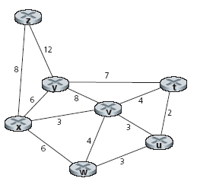

|  |  |  |  |  |  |  |  |
| --- | --- | --- | --- | --- | --- | --- | --- |
| Steps |  |  |  |  |  |  |  |
| 0 |  |  |  |  |  |  |  |
| 1 |  |  |  |  |  |  |  |
| 2 |  |  |  |  |  |  |  |
| 3 |  |  |  |  |  |  |  |
| 4 |  |  |  |  |  |  |  |
| 5 |  |  |  |  |  |  |  |
| 6 |  |  |  |  |  |  |  |

**Question 4: Topic: Distance Vector Routing [10 Points]**

Consider the three-node topology having nodes x, y and z and the link costs are *c*(*x,y*) = 4, *c*(*y,z*) = 35, *c*(*z,x*) = 3.

1. Compute the distance tables after the initialization step and after each iteration of a distance-vector algorithm until all distance tables will converge.
2. What will happen if the cost of link between y and x is increased to 51. how many iterations are required to converge the distance tables.

**Question 5: IP fragmentation [10 Points]**

A datagram of 5,000 bytes (20 bytes of IP header plus 4,980 bytes of IP payload) having identification number 32 arrives at a router must be forwarded to a link with a MTU of 1,000 bytes. complete the following table on the basis of fragmentation that is required here.

|  |  |  |  |  |
| --- | --- | --- | --- | --- |
| **Fragment** | **Bytes** | **ID** | **Offset** | **Flag** |
|  |  |  |  |  |

**Question 6: Topic – IP Subnetting [10 Points]**

For the network diagram below, label each of the end system with its IP address, default gateway and subnet mask. You need to consider that some subnets are already defined and their network addresses are already given.

**Question 7: Topic – Link layer, ARP and Switches [40 Points]**

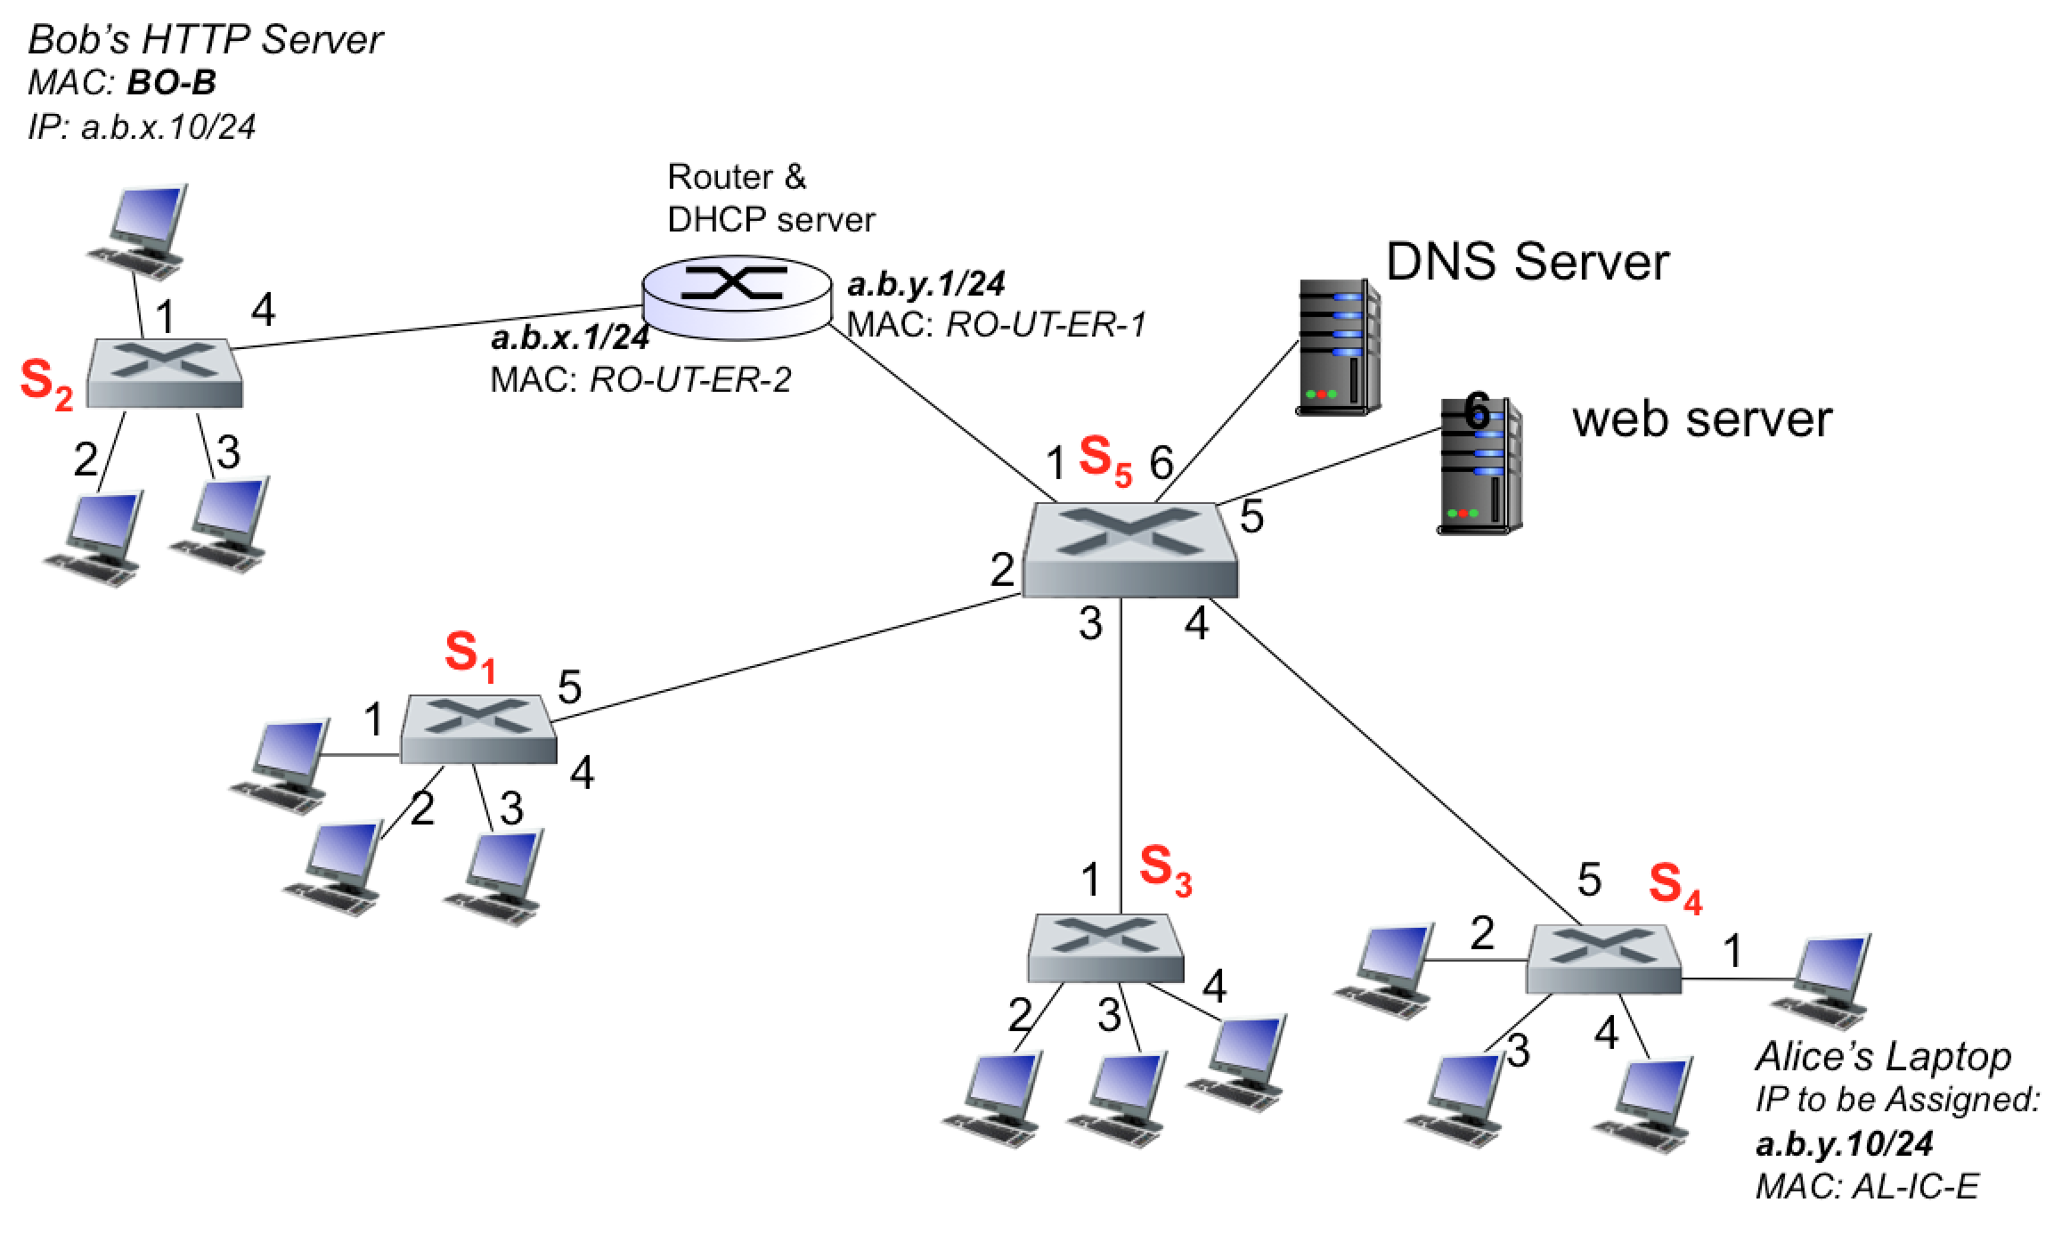

The network diagram above shows a typical university network setup. There are five switches S1 – S5. For the start we would assume that all Switch Tables (and so as ARP Tables) are empty. There are two subnets, ***a.b.x.0/24 and a.b.y.0/24***, separated by a router that also acts as the DHCP server. Switch S2 is not in the same subnet as of other switches. We identify few end systems here; Alice wants to join the network and should be assigned an IP address, ***a.b.y.10/24***. Bob is already there on the network but not in the same subnet and is running a Webserver at the assigned IPaddress, ***a.b.x.10/24****.* The MAC addresses of the different end systems are also shown in the figure.

While in a computer lab (where all systems are connected with S4), Alice plugs in network cable in her Laptop and first thing before she can access the network is to get an IP. She would use a well-known protocol (you should decide which one it is) and for simplicity, we only consider here one IP assignment request message, which once received by the server results in IP assignment. We would thus ignore the return journey from the server to Alice’s Laptop. You need to answer the following questions:

***Note: You need to be as specific as possible and provide the answers in the space provided. Anything written outside the allocated space (box) would not be considered for evaluation.***

a) What kind of Application layer message is sent by Alice’s Laptop and using which Application layer protocol?

**[3 points]**

b) What would the Transport layer do with this message, more specifically what critical information would the Transport layer add? You need to write concrete values and only show most critical information.

**[3 points]**

c) What would the Network layer do with this message, more specifically what critical information would the Network layer add? You need to write concrete values and only show most critical information.

**[3 points]**

d) Assuming the initial ARP (address resolution protocol) table is empty, what kind of ARP messages are needed for this request to reach the IP assigning server.

**[3 points]**

e) What would the Link layer do with this message, more specifically what critical information would the Link layer add? You need to write concrete values and only show most critical information.

**[3 points]**

f) Assuming the Ethernet link layer protocol is being used, which Multiple Access Protocol is used to sense the communication link before sending data? Is there any chance of collisions? Detail your reasoning.

**[1+2 points]**

g) How different switches help the message to reach its ultimate destination? You need to assume the switch tables were empty at the start and show the Switch Table for each switch separately.

**[6 points]**

h) As the switches attempt to find the ultimate destination, the message may get forwarded to incorrect recipients. How (at which layer) end systems decide action to be taken and what they do with the message?

**[3 points]**

i) Once the IP assigning server receives the request message, it allocates an IP address and sends a response message to Alice’s Laptop. What core information (other than IP address) is returned and why does Alice’s laptop need that information?

**[6 points]**

j) Suppose Alice wants to send a message to Bob’s HTTP server (Bob has created a special Web page for Alice!!), and to simplify the scenario, she knows the IP address of Bob’s Web server. She types in the Bob’s IP address in the browser and the typical process follows.

j1) You need to specify where, at which layer, the decision to use ARP protocol is made.

**[3 points]**

j2) In the ARP request message, what would the IP being queried using ARP? How does Alice’s Laptop decide where to send the message next?

**[3 points]**